Virologica Sinica

Supplementary Data

PRRSV degrades MDA5 via dual autophagy receptors P62 and CCT2 to evade antiviral innate immunity

Ruiqi Sun ^{a, 1}, Yanyu Guo ^{a, 1}, Lilin Zhang ^{a, 1}, Huixia Zhang ª, Boxuan Yin ª, Xiaoyang Li ª, Changyan Li ª, Liu Yang ª, Lei Zhang ª, Zexing Li ^{a,} *, Jinhai Huang ^{a,} *

ª School of Life Sciences, Tianjin University, Tianjin, 300072, China

*Corresponding author.
E-mail: jinhaih@tju.edu.cn (J. Huang)
ORCID: 0000-0002-1073-533X

¹ Ruiqi Sun, Yanyu Guo, Lilin Zhang contributed equally to this work.

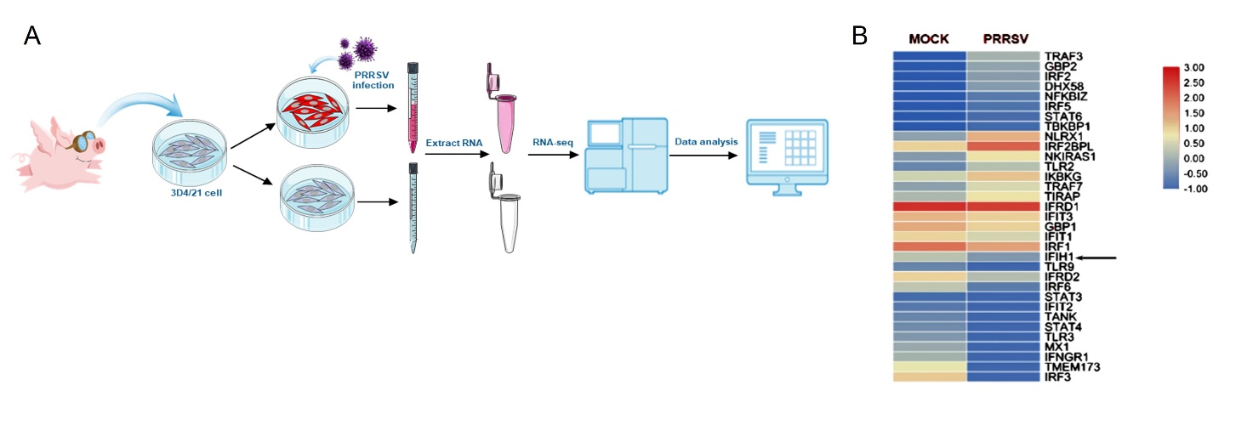
Figure. S1 A Diagram representation of transcriptome sequencing of 3D4/21^{CD163} cells uninfected and infected with PRRSV strain JXwn06 (MOI of 0.5). B Heat map with differential expression of molecules in the interferon signaling pathway upon PRRSV infection.

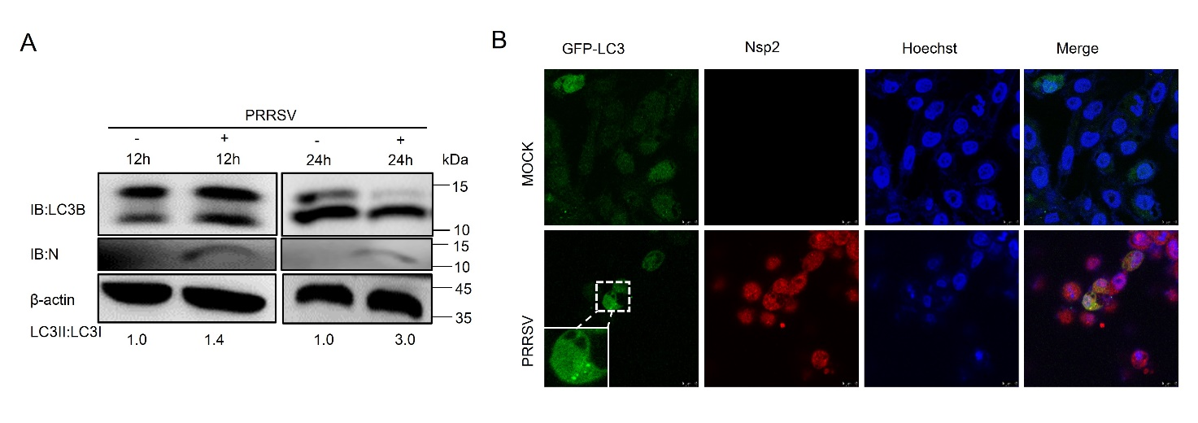
Figure. S2 PRRSV can induce autophagy. A 3D4/21^{CD163} cells were uninfected or infected with PRRSV for 12 and 24 h. The cell samples were harvested and lysed, and the protein expression levels of LC3 were detected by WB analysis. Quantification of band density in WB was done using ImageJ, and the ratio of the intensity of LC3-II to LC3-I was calculated to present the autophagic level. B 3D4/21^{CD163} cells were transfected with EGFP-LC3 plasmids and uninfected or infected with PRRSV for 24 h. The fixed cells were observed under confocal laser scanning microscope. Virions were stained with anti-PRRSV-Nsp2 protein pAb (red), and nuclei were stained with Hoechst (blue). Scale bars: 10 μm.

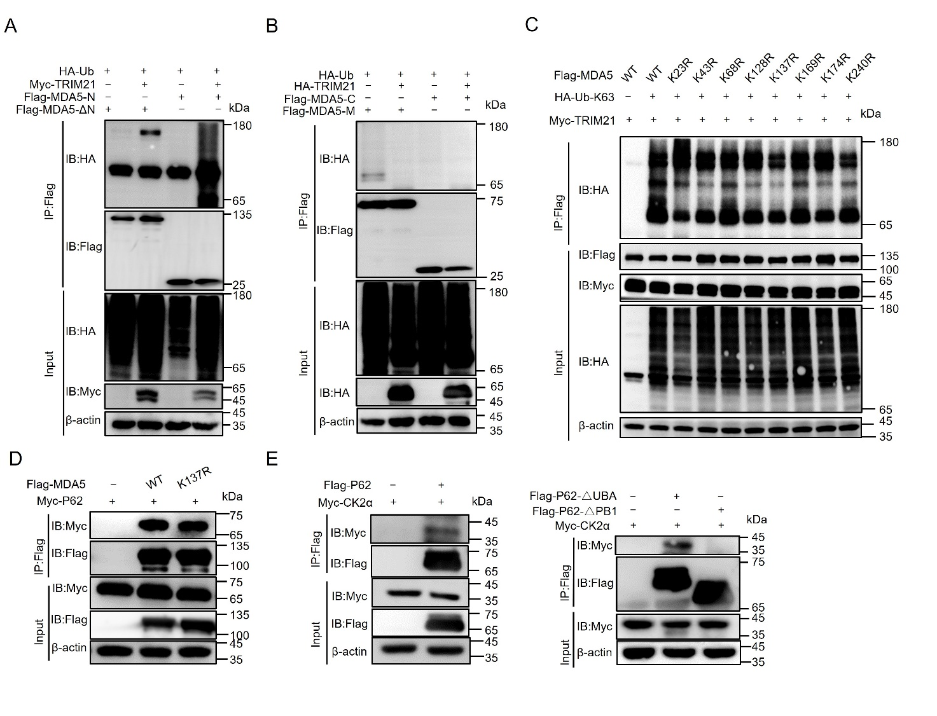
Figure. S3 Phosphorylase CK2α and ubiquitinase TRIM21 are involved in the selective autophagic degradation of MDA5. A-B Flag-MDA5 mutants and HA-Ub were cotransfected with or without Myc-TRIM21 into HEK 293T cells for 24 h. Cell lysates were subjected to immunoblot analysis of ubiquitination of MDA5 domains. C Immunoblot analysis of MDA5 ubiquitination in HEK 293T cells transfected with Myc-TRIM21, HA-K63-Ub, Flag-MDA5, or the K-to-R mutants of MDA5 N terminal domain. D Coimmunoprecipitation and immunoblot assays of extracts of HEK 293T cells transfected with Flag-MDA5 or Flag-MDA5 (K137R) and Myc-P62. E Coimmunoprecipitation and immunoblot analysis of the relation between Myc-CK2α with Flag-P62 or Flag-P62 (ΔPB1) or Flag-P62 (ΔUBA) in the lysates of cells.

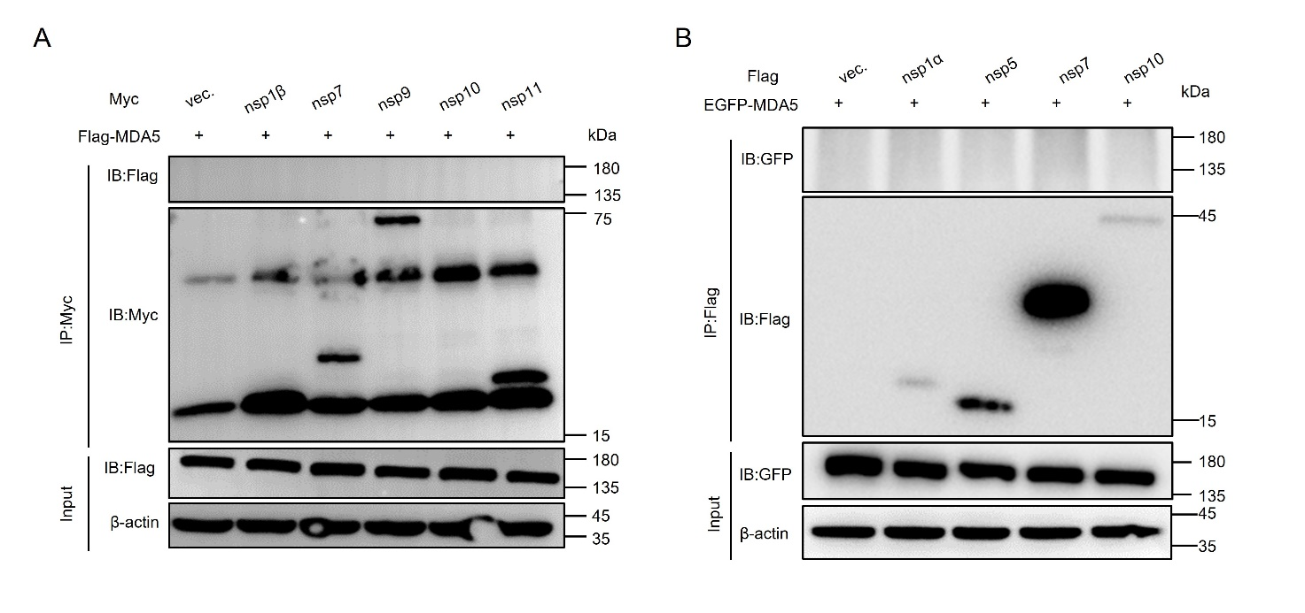
Figure. S4 No direct interaction of MDA5 with partial viral proteins of PRRSV was found. A-B Coimmunoprecipitation and immunoblot analysis of the relation between nsp1α, nsp1β, nsp5, nap7, nsp9, nsp10 or nsp11 with MDA5 in the lysates of HEK 293T cells, using anti-Myc beads or Flag beads.

Table S1 The primers used for PCR amplification
Primer name | Sequence of primer (5’-3’)
Flag-MDA5(sus)-F | CCAGTCGACTCTAGAGGATCCATGTCGTCGGATGGGTATTCC
Flag-MDA5(sus)-R | CAGGGATGCCACCCGGGATCCTCAGTCCTCATCACTAGACAAAC
EGFP-MDA5-F | TCGAGCTCAAGCTTCGAATTCTATGTCGTCGGATGGGTATTCC
EGFP-MDA5-R | GGATCCCGGGCCCGCGGTACCTCAGTCCTCATCACTAGACAAAC
Flag-MDA5-N-F | CCAGTCGACTCTAGAGGATCCATGTCGTCGGATGGGTATTC
Flag-MDA5-N-R | CAGGGATGCCACCCGGGATCCATCGGTGCCTGTTAATTCGC
Flag-MDA5-M-F | CCAGTCGACTCTAGAGGATCCGCATCCCCTGAGCCAGAGC
Flag-MDA5-M-R | CAGGGATGCCACCCGGGATCCGGCAACCAGGACGTAGGTGC
Flag-MDA5-C-F | CCAGTCGACTCTAGAGGATCCATGTACGTCCTGGTTGCCCA
Flag-MDA5-C-R | CAGGGATGCCACCCGGGATCCTCAGTCCTCATCACTAGACAAAC
Flag-MDA5-△C-F | AAGCAATGCAAGGACGAATATTGTTTGTCTAGT
Flag-MDA5-△C-R | GTCCTTGCATTGCTTTGCAAT
Flag-MDA5-△N-F | TCGGATGGGTATTCCTGCTGTGAAAGCAATGCAGAATCT
Flag-MDA5-△N-R | GGAATACCCATCCGACGACATGGATCC
PGL3-basic-MDA5-luc-F | ATCTGCGATCTAAGTAAGCTTCCTCAGAGCACTAATCCTCACC
PGL3-basic-MDA5-luc-R | CAGTACCGGAATGCCAAGCTTCTTTCCTTCTGAGAGGAGGG
PGL3-basic-MDA5-1-luc-F | CTAATCCTCACCGGGCGGATTGAATCCGAGCTGCAG
PGL3-basic-MDA5-2-luc-F | CTAATCCTCACCGGGCCAATCAGGCTCACCTGCAAG
PGL3-basic-MDA5-3-luc-F | CTAATCCTCACCGGGCCCAGGCTTCCCTGGCCTATC
PGL3-basic-MDA5-4-luc-F | CTAATCCTCACCGGGCCAGTCACCCAGGGCTGCAGA
PGL3-basic-MDA5-5-luc-F | CTAATCCTCACCGGGCCATTTTTCAGTGTGGGTGTCT
PGL3-basic-MDA5-6-luc-F | CTAATCCTCACCGGGCCTAGCTGCTTCAGCCAAAACT
PGL3-basic-MDA5-7-luc-F | CTAATCCTCACCGGGCGGTTCTTGGGGTTACACATC
PGL3-basic-MDA5-8-luc-F | CTAATCCTCACCGGGCCGTAGCGACGGCGTCTTG
PGL3-basic-MDA5-9-luc-F | CTAATCCTCACCGGGCCACTTCTCACCTGTGGAGC
PGL3-basic-MDA5-mutant-R | GCCCGGTGAGGATTAGTGCTCTGAG
Flag/HA-P62(sus)-F | CCAGTCGACTCTAGAGGATCCATGAGGGGCGGGGCTTC
Flag/HA-P62(sus)-R | CAGGGATGCCACCCGGGATCCTCACAAGGGCGGTGGGTG
Myc-P62-F | GAGGATCTGGGTACCGGATCCATGAGGGGCGGGGCTTC
Myc-P62-R | ATGCTCGAGGAATTCGGATCCTCACAAGGGCGGTGGGTG
Flag-P62-△PB1-F | GTCATGGCGTCGAAGGAGTGCCGGCGGGAC
Flag-P62-△PB1-R | CGACGCCATGACCACCAGTTG
Flag-P62-△UBA-F | ACAGGGCTGAAGGGATCCCGGGTGGCATCC
Flag-P62-△UBA-R | CTTCAGCCCTGTGGGTCCTTC
Flag-P62-△LIR-F | AGACATGGGCACCTCCAGTCTCTACAGATG
Flag-P62-△LIR-R | GTGCCCATGTCTCAGCTTCCG
HA-CCT2(sus)-F | CCAGTCGACTCTAGAGGATCCATGGCGTCCCTTTCCCTG
HA-CCT2(sus)-R | CAGGGATGCCACCCGGGATCCTTAACAGGGGTGGTGATC
Myc-CCT2-F | GAGGATCTGGGTACCGGATCCATGGCGTCCCTTTCCCTG
Myc-CCT2-R | ATGCTCGAGGAATTCGGATCCTTAACAGGGGTGGTGATC
Flag-CCT2-△D1-F | GACTCTAGAGGATCCGGCTTTCTGTTGGATAAA
Flag-CCT2-△D1-R | GGATCCTCTAGAGTCGACTGGTAC
Flag-CCT2-△D2-F | TCCTATTTAGATGAATCTGGGGTAGCCCTCGGT
Flag-CCT2-△D2-R | TTCATCTAAATAGGAATCTGCCAG
Flag-CCT2-△D3-F | GTAGCCCTCGGTGGATCCCGGGTGGCATCC
Flag-CCT2-△D3-R | ACCGAGGGCTACCCCAGAGAA
Flag/HA-TRIM21(sus)-F | CCAGTCGACTCTAGAGGATCCATGGCCTCAGCACTGCCC
Flag/HA-TRIM21(sus)-R | CAGGGATGCCACCCGGGATCCTCAGGGGGGGTGCATTTC
Myc-TRIM21-F | GAGGATCTGGGTACCGGATCCATGGCCTCAGCACTGCCC
Myc-TRIM21-R | ATGCTCGAGGAATTCGGATCCTCAGGGGGGGTGCATTTC
Myc-CSNK2A1(sus)-F | CTGGGTACCGGATCCGAATTCATGTCGGGACCCGTGCCA
Myc-CSNK2A1(sus)-R | AGATGCATGCTCGAGGAATTCTTACTGCTGAGCGCCAGCG
Myc-CSNK2A1(K68M)-F | AGTTGTTGTTATGATTCTCAAGCCAGTAAAG
Myc-CSNK2A1(K68M)-R | CATAACAACAACTTTTTCATTATTTGTGATG
Flag/Myc-TFAP2C(sus)-F | CCAGTCGACTCTAGAGGATCCATGTTGTGGAAAATAACCGATAATG
Flag/Myc-TFAP2C(sus)-R | CAGGGATGCCACCCGGGATCCTTACTTCCTGTGCTTCTCCAGC
PGL3-basic-MDA5-4-1-luc-F | ACCGGGCCAGTCACCCAGCTATGCAGAGCATC
PGL3-basic-MDA5-4-1-luc-R | TAGCTGGGTGACTGGCCCGGTGAGGATTAG
PGL3-basic-IFN-β(sus)-F | ATCTGCGATCTAAGTAAGCTTACTTGGCTTATGGTGG
PGL3-basic-IFN-β(sus)-R | CAGTACCGGAATGCCAAGCTTTGATGAAAACGGAAACACGG
Flag-nsp1α-F | CAAGCTTGCGGCCGCGAATTCAATGTCTGGGATACTTGATCG
Flag-nsp1α-R | CAGGGATGCCACCCGGGATCCTCAAGCACACTCAAAAGGGC
Myc-nsp1β-F | GAGGATCTGGGTACCGGATCCGCTGACGTCTATGACATTGG
Myc-nsp1β-R | ATGCTCGAGGAATTCGGATCCTCAACCGTACCACTTATGAC
Myc-nsp3-F | GAGGATCTGGGTACCGGATCCGGCCCACACCTCATTGCTG
Myc-nsp3-R | ATGCTCGAGGAATTCGGATCCTCACTCAAGGAGGGACCCG
Myc-nsp4-F | GAGGATCTGGGTACCGGATCCGGCGCTTTCAGAACTCAAAAG
Myc-nsp4-R | ATGCTCGAGGAATTCGGATCCTCATTCCAGTTCGGGTTTGG
Flag-nsp5-F | CAAGCTTGCGGCCGCGAATTCAATGGGAGGCCTTTCCACAGT
Flag-nsp5-R | CAGGGATGCCACCCGGGATCCTCACTCGGCAAAGTATCGCA
Myc-nsp7-F | GAGGATCTGGGTACCGGATCCTCGCTGACTGGTGCCCTCG
Myc-nsp7-R | ATGCTCGAGGAATTCGGATCCTCATTCCCACTGAGCTCTTC
Myc-nsp9-F | GAGGATCTGGGTACCGGATCCTTTAAACCTGCTAGCCGCCA
Myc-nsp9-R | ATGCTCGAGGAATTCGGATCCTCACTCATGATTGGACCTGAG
Myc-nsp10-F | GAGGATCTGGGTACCGGATCCGGGAAGAAGTCCAGAATGTG
Myc-nsp10-R | ATGCTCGAGGAATTCGGATCCTCATTCCAGGTCTGCGCAA
Myc-nsp11-F | GAGGATCTGGGTACCGGATCCGGGTCGAGCTCCCCGCTC
Myc-nsp11-R | ATGCTCGAGGAATTCGGATCCTCATTCAAGTTGAAAATAGG
Myc-N-F | GAGGATCTGGGTACCGGATCCCCAAATAACAACGGCAAGCA
Myc-N-R | ATGCTCGAGGAATTCGGATCCTCATGCTGAGGGTGATGCTGT

Table S2 The primers used for qRT-PCR amplification
Primer name | Sequence of primer (5’-3’)
MDA5(sus)-F | TCAGACACAAGTTTGGCAGAAGG
MDA5(sus)-R | CATGGTGCCTGAATCACTGCC
IFN-β(sus)-F | AGCACTGGCTGGAATGAAACCG
IFN-β(sus)-R | CAGGTCATCCATCTGCCCATCAAG
CK2α(sus)-F | GGTGAGGATAGCCAAGGTTCTG
CK2α(sus)-R | TCACTGTGGACAAAGCGTTCCC
TFAP2C(sus)-F | CACCTGTTGCTGCACGATCAGA
TFAP2C(sus)-R | AGGAGCGACAATCTTCCAGGGA
TRIM21(sus)-F | CCAGACTCCCCTCTACCCT
TRIM21 (sus)-R | GCCGTGGTCACTGATGTTG
CCT2(sus)-F | TTTGGTGCTGCTGGTGTTATGG
CCT2(sus)-R | ACCACCTGTGACAAGAGCAAGG
PRRSV-N-F | CAGTCAATCAGCTGTGCCAAA
PRRSV-N-R | ATCTGACAGGGCACAAGTTCCA
β-actin(sus)-F | GAATCCTGCGGCATCCACGA
β-actin (sus)-F | CTCGTCGTACTCCTGCTTGCT

