Virologica Sinica

Supplementary Data

Direct Infection of SARS-CoV-2 in Human iPSC-Derived 3D Cardiac Organoids Recapitulates COVID-19 Myocarditis

Weijie Wang^{a,c,1}, Jinxuan Yang^{b,1}, Pinfang Kang^{a,1,*}, Jinsong Bai^{d,1}, Xiaoli Feng^{e,1}, Liuqi Huang^{c}, Yiming Zhang^{c}, Yuechun Wu^{b}, Bi Tangª, Hongju Wangª, JianJie Jiang^{d}, Minghua Li^{e}, Bing Zhao^{c,f,*} and Xinglou Yang^{b,*}
ªDepartment of Cardiovascular Disease, The First Affiliated Hospital of Bengbu Medical College, Bengbu, 233004, China;
^{b}Yunnan Key Laboratory of Biodiversity Information, Kunming Institute of Zoology, Chinese Academy of Sciences, Kunming, 650023, China;
^{c}State Key Laboratory of Genetic Engineering, School of Life Sciences, Zhongshan Hospital, Fudan University, Shanghai, 200438, China;
^{d}Kunming Third People's Hospital, Kunming, 650041, China;
^{e}Kunming National High-level Biosafety Research Center for Non-human Primates, Kunming Institute of Zoology, Chinese Academic of Sciences, Kunming, 650107, China;
^{f}Institute of Organoid Technology, Kunming Medical University, Kunming, 650500, China.

*Corresponding authors.
E-mail address: kangpinfang.1016@163.com (P. Kang), bingzhao@fudan.edu.cn (B. Zhao), yangxinglou@mail.kiz.ac.cn (X. Yang)
ORCIDs:
0000-0001-9891-3569 (B. Zhao)
0000-0003-0556-1088 (P. Kang)
0000-0002-5317-8983 (X. Yang)

1 Weijie Wang, Jinxuan Yang, Pinfang Kang, Jinsong Bai, Xiaoli Feng contributed equally to this work.
Supplementary Information
Materials and Methods
Generation of Cardiac organoids
The hiPSC were harvested at approximately 70% confluency. Then hiPSC were seeded at 5,000 cells/ well in a volume of 200 μL into U bottom ultra-lowattachment 96-well plates containing hiPSC medium + 10 μmol/L Y27632 for 24 h. Then cells were induced for 2 days with the Stage 1 medium. After 2 days, cells were induced with Stage 2 medium for 4 days with medium change every 2 days. Subsequently, the medium was changed to Stage 3 medium with medium change every 2 days (Hofbauer et al., 2021). Until day 20, matured cardiac organoids were subjected to the corresponding experiments. The medium compositions were shown in Supplementary Table S1.
Cryosectioning of cardiac organoids
Cardiac organoids (COs) were fixed with 4% PFA (Servicebio, G1101) for overnight at 4℃ and washed three times in 1×PBS (Gibco, #14190094). Fixed COs were then soaked with 30% sucrose for overnight at 4 °C and embedded in O.C.T. cryoembedding medium (SAKURA, #4583) using a plastic mold (Bagley et al., 2017). After complete freezing under –80 °C, cardiac organoids were sectioned on CryoStar NX50 and the cryosections were collected on Ultra Plus slides and kept at –20 °C or –80 °C until immunostaining.
Immunofluorescence staining
For whole mount staining, 4% PFA-fixed COs was washed twice in 1x PBS and once in PBST for 15 min each. For crysectioned slides staining, O.C.T. was removed by washing with PBS before the immunostaining steps (Bagley et al., 2017). Then samples were incubated in blocking solution consisting of PBS with 4% goat serum (Beyotime, C0265) and 0.2% Triton X-100 (Sigma-Aldrich, #T8787) for 1 h (Hofbauer et al., 2021). The primary antibody was subsequently applied in above blocking buffer for overnight at 4℃ in the case of the 2D samples and 2 days at 4 °C on a shaker for 3D samples (Drakhlis et al., 2021; Lewis-Israeli et al., 2022). Following washing twice with PBS/Tween20, 3D tissues were incubated with the secondary antibody solution at 4 °C on a shaker for 2 h while 2D samples were incubated up to 1 hour at room temperature. Following these washing steps and an additional PBS wash, tissues were ready for analysis, while slides were mounted using fluorescence mounting medium (Beyotime, P0128S)
Virus infection and detection
COs were used to study replication dynamic of SARS-CoV-2, including wild-type, Omicron BA.5. COs were infected with SARS-CoV-2 at an MOI of 5. After incubation 1–2 h, cardiac organoids were washed and fresh medium was supplemented to COs (Zhao et al., 2021; Khan et al., 2022; Monteil et al., 2022). At different time points after infection, the cell supernatants were collected to extract viral RNA using viral DNA/RNA extraction kit (Tianlong, T050). COs were harvested to extract total RNA using RNAiso plus (Takara, 9109). Subsequently, the RNA was subjected to one-step qPCR (Vazyme, P611-01). Primers used were listed in Supplementary Table S2.
Real-time qPCR
Total RNA was isolated from organoids by RNAiso Plus (Takara, 9109) and reverse-transcribed into cDNA with M-MLV Reverse Transcriptase (Invitrogen, 28025013) in biosafety level 2 facility strictly following the regulations. Quantitative real-time PCR was performed on CFX384 Touch System (Bio Rad). Primers used were listed in Supplementary Table S2.
RNA-Seq and transcriptome bioinformatic analysis
Total RNA was extracted from COs by RNAiso Plus (Takara, 9109) in Biosafety level 3 facility according to strict regulations and then sent to the company (BIOLINKER) for quality control and sequencing. Libraries were sequenced on an Illumina NovaSeq 6000 platform. After quality control, clean reads were aligned to human reference genome (GRCh38) using HISAT2 (version 2.2.1). The alignments were then passed to StringTie (version 2.2.1) to assemble and quantify the transcripts in each sample. Differentially expressed genes (DEGs) were identified by the R package edgeR (version 1.0.12). Genes were defined as DEGs if it possesses the following characteristics: 1) gene expression (FPKM) > 1 in any sample, 2) absolute log2 (fold change) > 1.5) P-value < 0.05. Visualization and hierarchical clustering of log2-transformed FPKM was generated by pheatmap (version 1.0.12). GO/KEGG analysis were conducted using enrichGO/enrichKEGG function from ClusterProfiler package (version 4.7.1.00), GSEA analysis was conducted using the ClusterProfiler, with the hallmark gene sets acquired from GSEA database (http://www.gsea-msigdb.org/gsea/index.jsp).
Statistical analysis
We employed Student’s t-test or ANOVA test to analyze the parametric experimental results. Significant differences were noted with asterisks.

Table S1 Composition of cardiac organoids differentiation medium
Composition | Stage 1 | Stage 2 | Stage 3
Advanced DMEM F12 | + | + | +
BSA (5 mg/mL) | + | + | +
Monothioglycerol (MTG) (450 μmol/L) | + | + | +
CD lipid concentrate (100× ) | + | + | +
Insulin-transferrin-Selenium (100× ) | + | + | +
L-Ascorbic Acid 2-phosphate (50 μg/mL) | + | + | +
FGF2 | 30 ng/mL | 8 ng/mL | 8 ng/mL
LY294002 | 5 μmol/L | - | -
Activin A | 50 ng/mL | - | -
BMP4 | 10 ng/mL | 10 ng/mL | 10 ng/mL
CHIR99021 | 4 μmol/L | - | -
insulin | 1 μg/mL | 10 μg/mL | 10 μg/mL
Y27632 | 5 μmol/L | - | -
IWP2 | - | 5 μmol/L | -
Retinoic acid | - | 0.5 μmol/L | -
VEGF165 | - | - | 100 ng/mL

Table S2 Primers for qPCR
qPCR primers | Forward (5'–3') | Reverse (5'–3')
RBD | CAATGGTTTAACAGGCACAGG | CTCAAGTGTCTGTGGATCACG
GAPDH | GAAGGTGAAGGTCGGAGTC | GAAGATGGTGATGGGATTT
MYH6 | CGGTGCTTTTCAACCTCAAGG | GGACTGGTTCTCCCGATCTGT
MYL7 | GCCCAACGTGGTTCTTCCAA | CTCCTCCTCTGGGACACTC
TNNT2 | TTCACCAAAGATCTGCTCCTCGCT | TTATTACTGGTGTGGAGTGGGTGTGG
ACTC1 | GCTGTCTTCCCGTCCATC | CATGCTCGATGGGATACTTCAG
PLN | ACCTCACTCGCTCAGCTATAA | CATCACGATGATACAGATCAGCA
TRDN | TCACAGAAGACATAGTGACGACG | TGGCAATAGAGCTTGCTGAAA
ICAM1 | ATGCCCAGACATCTGTGTCC | GGGGTCTCTATGCCCAACAA
ICAM4 | ATGCCCAGACATCTGTGTCC | GGGGTCTCTATGCCCAACAA
GDF2 | AGAACGTGAAGGTGGATTTCC | CGCACAATGTTGGACGCTG
A2M | CGGAGAATGACGTACTCCACT | TGGGTTGGTCCTTTCACTTGG
VEGFA | AGGGCAGAATCATCACGAAGT | AGGGTCTCGATTGGATGGCA
THBD | ACCTTCCTCAATGCCAGTCAG | CGTCGCCGTTCAGTAGCAA
IL6 | ACTCACCTCTTCAGAACGAATTG | CCATCTTTGGAAGGTTCAGGTTG
IL33 | GTGACGGTGTTGATGGTAAGAT | AGCTCCACAGAGTGTTCCTTG
IL2RB | CAGCGGTGAATGGCACTTC | GGCATGGACTTGGCAGGAA
CCL2 | CAGCCAGATGCAATCAATGCC | TGGAATCCTGAACCCACTTCT
TLR6 | AGACCTACCGCTGAAAACCAA | ACTCACAATAGGATGGCAGGA
TGFβ1 | GGCCAGATCCTGTCCAAGC | GTGGGTTTCCACCATTAGCAC
IFNβ1 | CTTGGATTCCTACAAAGAAGCAGC | TCCTCCTTCTGGAACTGCTGCA
IFNL1 | GTTCAAATCTCTGTCACCAC | TTCAGCTTGAGTGACTCTTC
ISG15 | GAGGCAGCGAACTCATCTTT | AGCATCTTCACCGTCAGGTC
BST2 | CACACTGTGATGGCCCTAATG | GTCCGCGATTCTCACGCTT
ACE2 | CATTGGAGCAAGTGTTGGATCTT | GAGCTAATGCATGCCATTCTCA
TMPRSS2 | CTTTGAACTCAGGGTCACCA | TAGTACTGAGCCGGATGCAC

Table S3 Reagent information
Antibodies
TNNT2 | Thermo, MA5-12960
CD31 | Abcam, ab28364
CD31 | Abcam, ab9498
ACE2 | CST, 4355S
ACE2 | Proteintech, 21115-1-Ap
SARS-COV-2 N protein | SinoBiological, 40143-R019
Goat anti-mouse IgG, Dylight 488 | A23210
Goat anti-rabbit IgG, Dylight 488 | A23220
Goat anti-mouse IgG, Dylight 594 | A23410
Goat anti-rabbit IgG, Dylight 594 | A23420
Chemicals, peptides, and recombinant proteins
FGF2 | MCE, HY-P7331
FGF2 | SinoBiological, 10014-HNAE
LY294002 | MCE, HY-10108
Activin A | MCE, HY-P70311
BMP4 | MCE, HY-P7007
BMP4 | R&D Systems, 314-BP-050
CHIR99021 | MCE, HY-10182
CHIR99021 | R&D Systems, RD-4423/50
insulin | MCE, HY-P0035
Y27632 | MCE, HY-10583
IWP2 | MCE, HY-13912
Retinoic acid | MCE, HY-12238
VEGF165 | MCE, HY-P70458
VEGF165 | Peprotech, AF-100-20
Other
Advanced DMEM F12 | GIBCO, 12634028
Bovine Serum Albumin (BSA) | Sigma, A1933
Monothioglycerol (MTG) | Sigma-Aldrich, M6145
Concentrated Lipids | GIBCO, #11905031
L-Ascorbic Acid 2-phosphate | Sigma-Aldrich, A8960
Insulin-Transferrin-Selenium | GIBCO, #41400045
mTeSR TM 1 | Stemcell, 85850
ReLeSR | Stemcell, 05872
Experimental models: Cell line
iPSC | DYR0100, ATCC

Supplementary Video S1 Representative beating of cardiac organoids (see separate video file).

Supplementary Figures
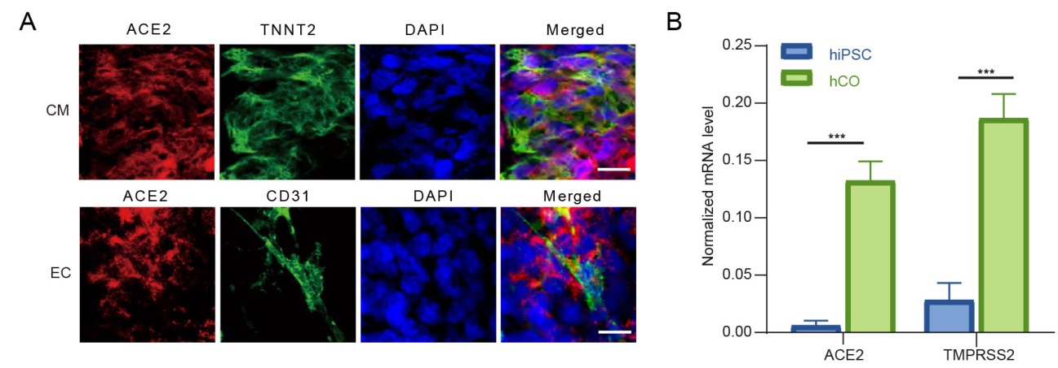
Fig. S1 The cardiac organoids and hiPSCs were tested by RT–qPCR to detect the transcriptional level of ACE2, TMPRSS2. GAPDH was used as an internal control. Data were presented as mean ± S.D. * indicates P < 0.05; ** indicates P < 0.01; *** indicates P < 0.001.

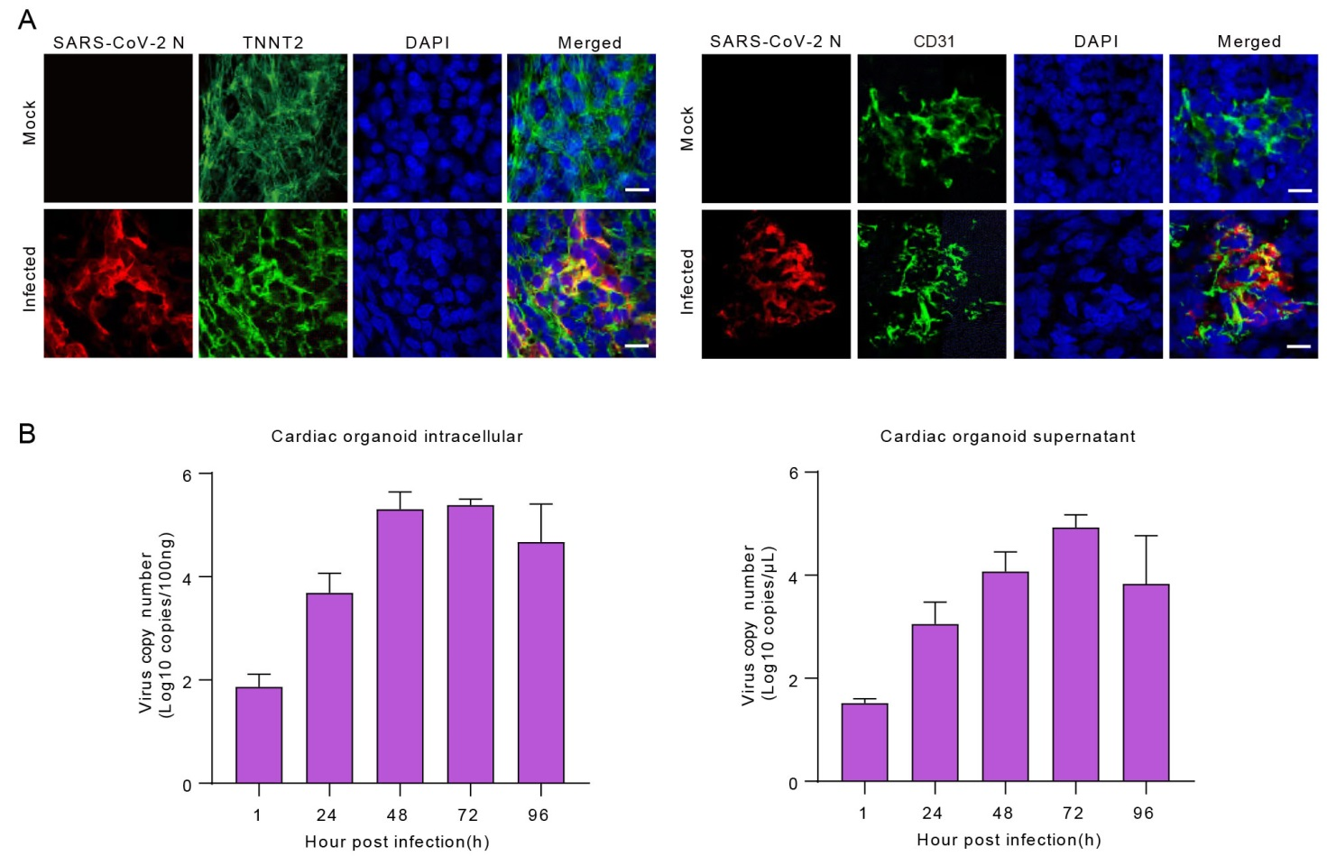
Fig. S2 A Immunofluorescence staining for SARS-CoV-2 N protein and TNNT2 in the cardiomyocytes、SARS-CoV-2 N protein and CD31 in the endothelial cells. Scale bar: 10 um. B Viral RNA copies were quantified in viral infected cardiac organoids in supernatant and cells.

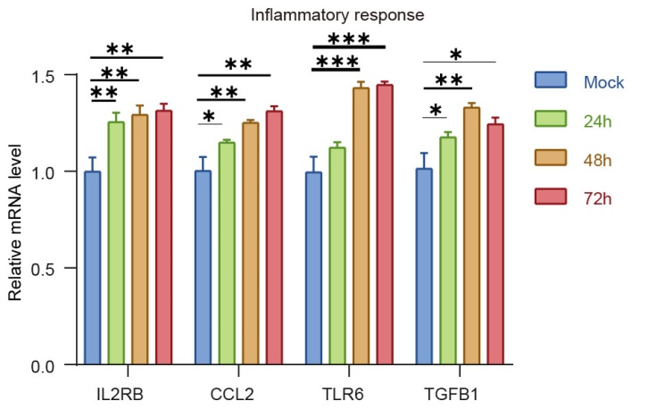
Fig. S3 The cardiac organoids after SARS-CoV-2 infection were harvested to examine the expression of indicated genes using qRT-PCR. GAPDH was used as an internal control. Data were presented as mean ± S.D. * indicates P < 0.05; ** indicates P < 0.01; *** indicates P < 0.001.

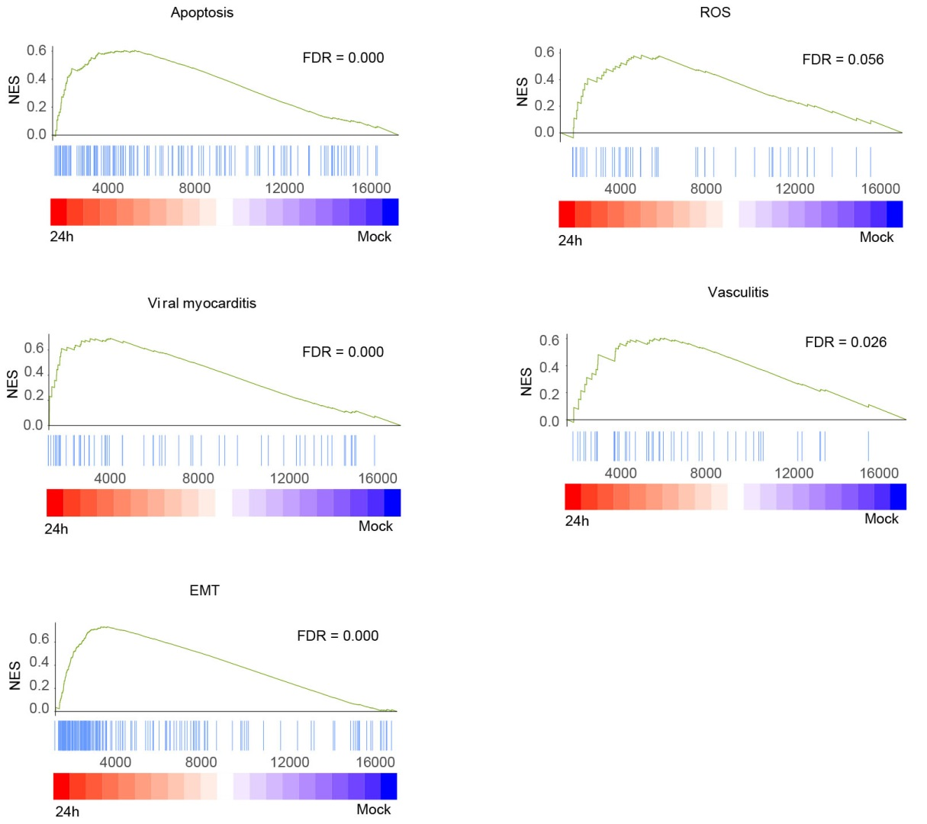
Fig. S4 GSEA enrichment analysis of SARS-CoV-2-infected organoids (Inf) (24 h) versus the mock (Mo).
References
Hofbauer, P., Jahnel, S. M., Papai, N., Giesshammer, M., Deyett, A., Schmidt, C., Penc, M., Tavernini, K., Grdseloff, N., Meledeth, C., Ginistrelli, L. C., Ctortecka, C., Šalic, Š., Novatchkova, M., & Mendjan, S. 2021. Cardioids reveal self-organizing principles of human cardiogenesis. Cell, 184, 3299–3317.e22.
Bagley, J. A., Reumann, D., Bian, S., Lévi-Strauss, J., & Knoblich, J. A. 2017. Fused cerebral organoids model interactions between brain regions. Nature methods, 14(7), 743–751.
Drakhlis, L., Devadas, S. B., & Zweigerdt, R. 2021. Generation of heart-forming organoids from human pluripotent stem cells. Nature protocols, 16, 5652–5672.
Lewis-Israeli, Y. R., Wasserman, A. H., Gabalski, M. A., Volmert, B. D., Ming, Y., Ball, K. A., Yang, W., Zou, J., Ni, G., Pajares, N., Chatzistavrou, X., Li, W., Zhou, C., & Aguirre, A. 2021. Self-assembling human heart organoids for the modeling of cardiac development and congenital heart disease. Nature communications, 12, 5142.
Zhao, B., Ni, C., Gao, R., Wang, Y., Yang, L., Wei, J., Lv, T., Liang, J., Zhang, Q., Xu, W., Xie, Y., Wang, X., Yuan, Z., Liang, J., Zhang, R., & Lin, X. 2020. Recapitulation of SARS-CoV-2 infection and cholangiocyte damage with human liver ductal organoids. Protein & cell, 11, 771–775.
Khan, A. O., Reyat, J. S., Hill, H., Bourne, J. H., Colicchia, M., Newby, M. L., Allen, J. D., Crispin, M., Youd, E., Murray, P. G., Taylor, G., Stamataki, Z., Richter, A. G., Cunningham, A. F., Pugh, M., & Rayes, J. 2022. Preferential uptake of SARS-CoV-2 by pericytes potentiates vascular damage and permeability in an organoid model of the microvasculature. Cardiovascular research, 118, 3085–3096.
Monteil, V., Kwon, H., Prado, P., Hagelkrüys, A., Wimmer, R. A., Stahl, M., Leopoldi, A., Garreta, E., Hurtado Del Pozo, C., Prosper, F., Romero, J. P., Wirnsberger, G., Zhang, H., Slutsky, A. S., Conder, R., Montserrat, N., Mirazimi, A., & Penninger, J. M. 2020. Inhibition of SARS-CoV-2 Infections in Engineered Human Tissues Using Clinical-Grade Soluble Human ACE2. Cell, 181, 905–913.e7.

