Virologica Sinica

Supplementary Data

Development of rapid nucleic acid assays based on the recombinant polymerase amplification for monkeypox virus

Yuchang Li ^{a, 1}, Yanhong Gao ^{b, 1}, Ying Tang ª, Jing Li ª, Sen Zhang ª, Tao Jiang ^{a,} * Xiaoping Kang ^{a,} *

¹State Key Laboratory of Pathogen and Biosecurity, The Academy of Military Medical Science, Institute of Microbiology and Epidemiology, Beijing 100071, China;
²Laboratory Department of the First Medical Center, Chinese PLA General Hospital, Beijing 100850, China;

¹ Yuchang Li and Yanhong Gao Contributed equally to this work.

Corresponding authors:
Email Addresses: kangxiaoping@bmi.ac.cn (X. Kang); jiangtao@bmi.ac.cn (T. Jiang)
ORCID: 0000-0002-0587-399X (X. Kang); 0000-0003-1908-2926 (T. Jiang)

Materials and methods
Quantitative PCR assay for MPXV
The qPCR reaction contained 5 µL extracted DNA, 5 µL of 4× TaqMan Fast Virus 1-step mix (Applied Biosystems,Vilnius, Lithuania), 1 µL of forward primer (10 µmol/L), 1 µL of reverse primer (10 µmol/L), 0.5 µL of probe (10 µmol/L), The sequences of the primers and probe was were as follows: Forward: 5′-ACGTGTTAAACAATGGGTGATG-3′, Reverse:5′-AACATTTCCATGAATCGTAGTCC-3′; Probe: 5′FAM-TGAATGAATGCGATACTGTATGTGTGGG-BHQ1, and 7.5 µL of sterile deionized water; final volume was 20 µL. Reactions were performed in a LightCycler 480 Real Time PCR instrument (Roche Diagnostics, Mannheim,Germany). Amplification conditions were as follows: reverse transcription at 50 °C for 5 min; pre-denaturation at 95 °C for 10 sec; and 45 cycles of PCR amplification consisting of denaturation at 95 °C for 5 sec, annealing at 58 °C for 30 sec, and fluorescence measurement, the cycle threshold (CT) value was calculated automatically by the software LCS480, the samples was deemed MPXV positive with the CT < 40.

Supplemental Table S1. Primer and probe sequences for F-RPA /VF-RPA assay
Primer name | Sequence (5′ to 3′) | Position (size, bp)
B7R-F1 | acgtgttaaacaatgggtgatggatacact | 168891–168920 (30)
B7R-R1 | aacatttccatgaatcgtagtccggtaccc | 168960–168989 (30)
B7R-F2 | agtacgtactatgccaaatgaatcacgtgtta | 168867–168898 (32)
B7R-R2 | aatcgaaaaacatttccatgaatcgtagtc | 168968–168997 (30)
B7R-Probe | tggatacacttaatggtataatgatgaatgFHQgcgatactgtatgtgtgg-[3′-block] | 168911–168962 (52)
B7R-R1-VF | [5′-biotin]-aacatttccatgaatcgtagtccggtaccc | 168960–168989 (30)
B7R-Probe-VF | FtggatacacttaatggtataatgatgaatgaaHgcgatactgtatgtgtgg-[3′-block] | 168911–168962 (52)
F: FAM-dT, thymidine nucleotide carrying fluorescein; H: THF, tetrahydrofuran spacer; Q: BHQ1-dT, thymidine nucleotide carrying Black-Hole Quencher 1; 3′-block: 3′-phosphate introduced to block elongation. Numbers in position column are primer positions according to Monkeypox virus strain Cote d'Ivoire_1971 (accession no. KP849470.1).

Supplemental Table S2. Ten MPXV Samples used for the F-RPA/VF-RPA validation
Sample No. |  | Results
 | F-RPA | VF-RPA | qPCR (CT value)
A1 | P | P | 28.59
A2 | P | P | 32.77
A3 | P | P | 32.32
B1 | P | P | 31.16
CL1 | P | P | 32.17
CL2 | P | P | 36.50
PW1 | P | P | 35.09
PW2 | P | P | 37.02
NGS1 | P | P | 27.28
NGS2 | P | P | 28.22
P: positive results. For the qPCR assay, the sample is deemed positive with CT value < 40.

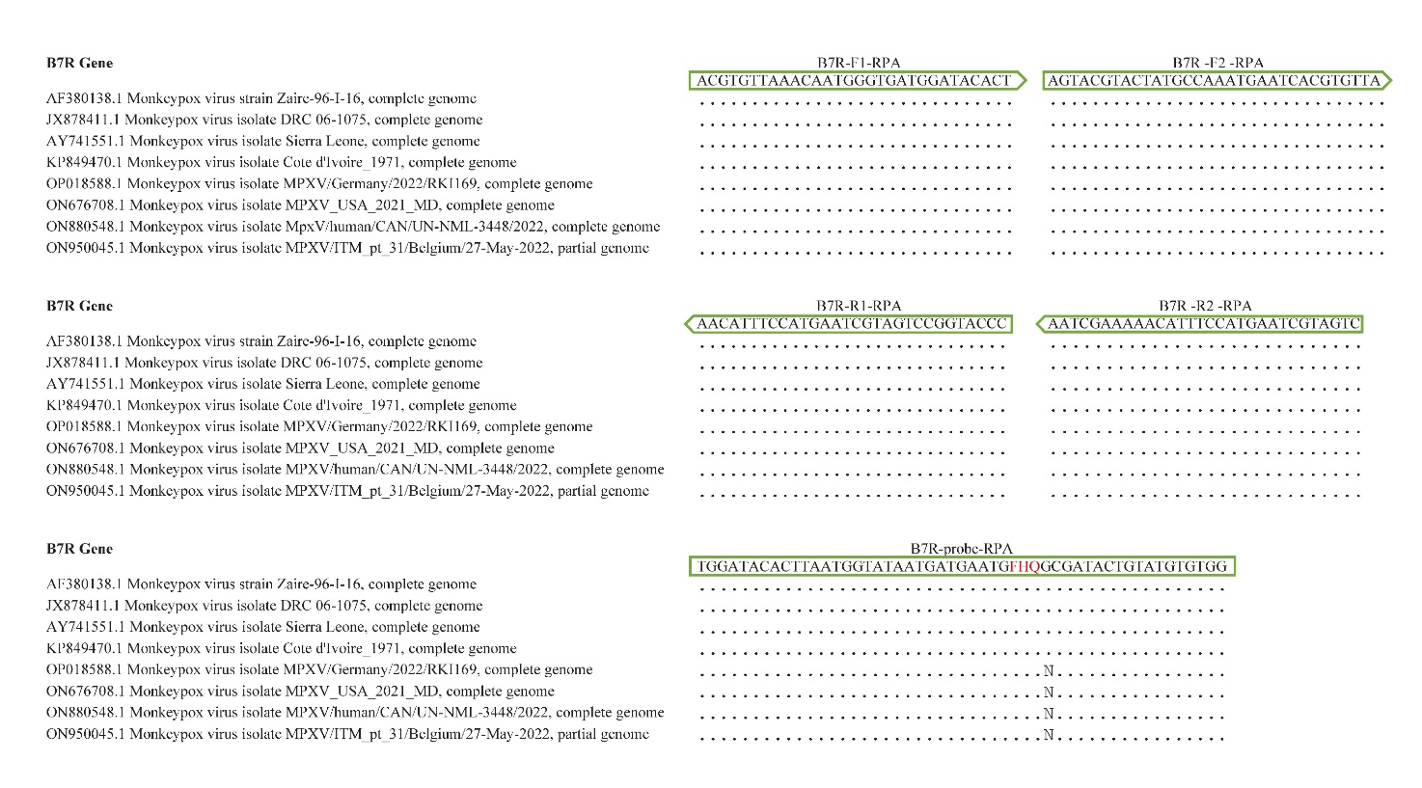
Supplemental figure S1. Partial alignment of the oligonucleotide binding regions in the MPXV genome (n = 8). Dots represent nucleotides that are identical to the MPXV Cote d’Ivoire_1971 (accession no. KP849470.1) isolate. N: mismatched nucleotide. Green arrow and box: sequences of the primers and probe used for the RPA assay.

